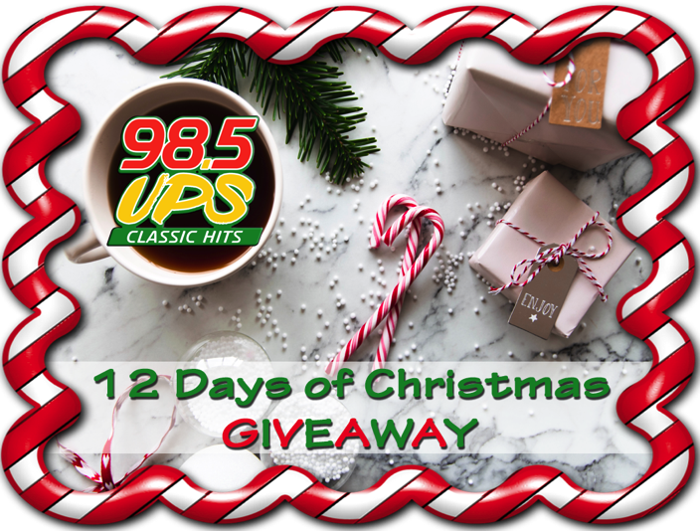

Day 12 Thursday 12/5
Ron Watson from Roscommon
$100 Northwood’s Outlet Gift Card, A pair of tickets to all remaining home CMU Men’s Basketball Games with a parking pass and $100 in Comfort Cash from the Comfort Center

Day 11 Friday 12/6
Table Top Weber Grill from Northwoods, A Solar Automatic Battery Charger from West Branch Automotive and $100 in Comfort Cash from the Comfort Center

Day 10 Monday 12/9
$100 N.W. Gift Card, A Deluxe Telescoping pet ramp from Packy’s Pets and Supplies in Houghton Lake and $100 in Comfort Cash from the Comfort Center
Day 9 Tuesday 12/10
Table Top Weber Grill from Northwoods, Family 4 pack of tickets to the Toughest Monster Truck Tour at the Dow Event Center with pit passes and a Bundle of goodies for the family from Bob’s Party Store in Harrison
Day 8 Wednesday 12/11
8 ft. Kayak with paddle and 3 buckle life vest from Northwood’s, $200 towards service at Don Nester Auto Group in Houghton Lake,

Day 7 Thursday 12/12
Table Top Weber Grill from Northwoods, $150 Gift Certificate to Becky’s Best Sewing Machines in Houghton Lake and $100 in Comfort Cash from the Comfort Center

Day 6 Friday 12/13
$100 N.W. Gift Card, A pair of tickets to all remaining home CMU Men’s Basketball Games with a parking pass and $100 in Comfort Cash from the Comfort Center

Day 5 Monday 12/16
Table Top Weber Grill from Northwoods, Family 4 pack of tickets to the Toughest Monster Truck Tour at the Dow Event Center with pit passes,

Day 4 Tuesday, 12/17
8 ft. Kayak with paddle and 3-buckle life vest from Northwood’s, a pair of tickets to the United By Sacrifice Concert featuring the Guess Who,

Day 3 Wednesday, 12/18
$100 N.W. Gift Card, A Pair of tickets to see Theresa Caputo at the Soaring Eagle Resort March 7th,

Day 2 Thursday, 12/19
8 ft. Kayak with paddle and 3 buckle life vest from Northwoods, A complete vehicle detailing from Maverick Ford in Gladwin, A pair of tickets to the United By Sacrifice Concert featuring the Guess Who,

Day 1 Friday, 12/20
8 ft. Kayak with paddle and 3 buckle life vest from Northwoods, A pair of tickets to see Ratt and Quiet Riot at the Soaring Eagle Casino and Resort on Dec 30th, a $50 Mastercard Gift Card from Isabella Bank

December 2019

