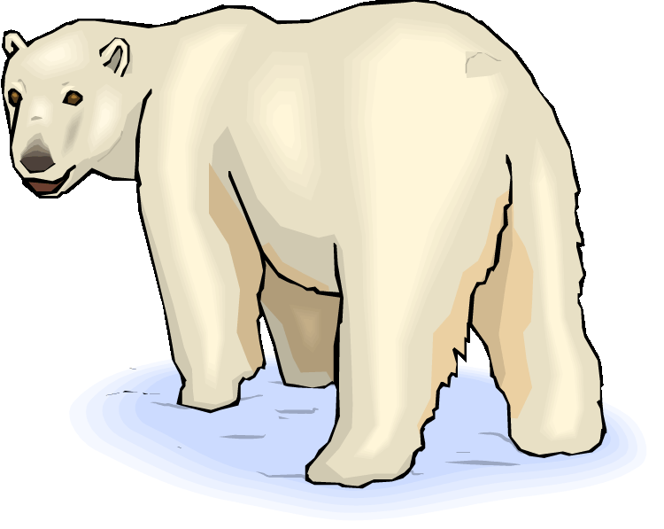
POLAR BEAR DIP GUIDELINES

Rules may change pending committee meeting.

* NO PRE-REGISTRATION, Participants can fill out waivers at the site or pick one up from the Chamber ahead of time.
* Sign -Up begins at noon.
* All participants must sign a waiver. The waiver must be completed in full, legible, signed.
* First 4 participants who purchased their dip at the kick-off auction on Jan. 6th do not have to wait in line.
* Must have a festival badge
* Must be 18 years old or 16 with a parent or guardian present. Participants under the age of 16 will not be allowed to participate.
* Please notify at registration if you are a Foreign Exchange Student.
* Participants must understand live filming, social media, photographers and media personnel, etc. that may be part of a national or international audience will be present.
* $25 Entry Fee per person
* Awards will be given out in the following categories:
* Best Overall Dip
* Best Belly flop
* Best Cannonball
* Best Dressed
* Most Creative Dip
* Oldest Dipper
* Farthest Traveled Dipper
* Most Frequent Dipper
* No alcoholic beverages or consumption of alcohol. If it is suspect you have consumed alcohol, you may be denied participation.
* Participants will not be under the influence of any drugs or substance that impairs their faculties.
* Must wear shoes while on the ice
* Dressing tents will be available
* Sweatshirts will be guaranteed to the first 75 participants. No sweatshirts will be available for purchase. No exceptions.

